**DAILY ONLINE ACTIVITIES SUMMARY**

|  |  |  |  |  |  |  |  |  |
| --- | --- | --- | --- | --- | --- | --- | --- | --- |
| **Date:** | **23/05/2020** | | | | | **Name:** | **Katira Krishna J** | |
| **Sem & Sec** | **8th A** | | | | | **USN:** | **4AL16CS045** | |
| **Online Test Summary** | | | | | | | | |
| **Subject** | | **IOT** | | | | | | |
| **Max. Marks** | |  | | **Score** | | |  | |
| **Certification Course Summary** | | | | | | | | |
| **Course** | **Machine learning with python** | | | | | | | |
| **Certificate Provider** | | | **Cognitiveclass.ai** | | **Duration** | | | **12 Hours** |
| **Coding Challenges** | | | | | | | | |
| **Problem Statement:**  Python program to check whether the strings are anagram | | | | | | | | |
| **Status: Completed** | | | | | | | | |
| **Uploaded the report in Github** | | | | | **yes** | | | |
| **If yes Repository name** | | | | | **Krishna_Katira** | | | |
| **Uploaded the report in slack** | | | | | **yes** | | | |

Online Test Details:

Test Not Conducted

Certification Course Details:

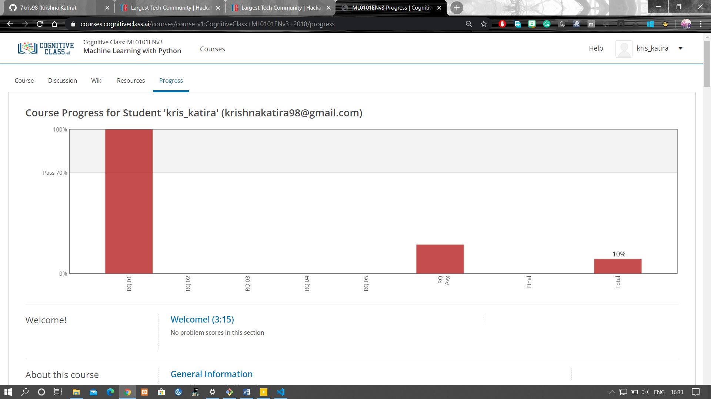

Coding Challenges Details:

**program1**

**To check whether strings are anagram**

def check(s1, s2): #Check sorted strings

if(sorted(s1)== sorted(s2)):

print("anagrams.")

else:

print("Not anagrams.")